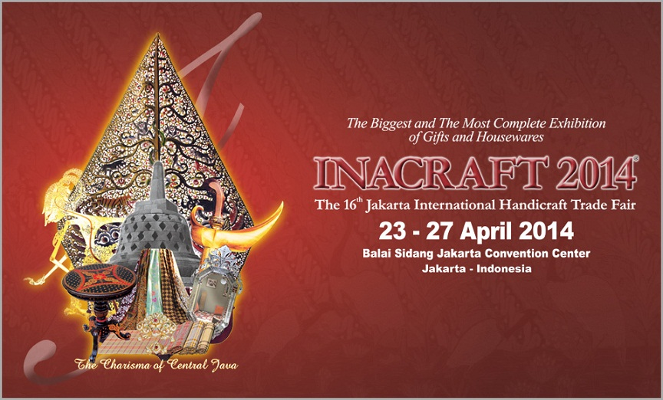
Jakarta INACRAFT 2014
4D 3N
Periode : 23 – 27 April 2014

Day 01 : Arrive in Jakarta ( L , D )
Arriving in Jakarta ( ETA 09:45 ) participants will be taken around the city after lunch at loakl restaurant and went straight to the hotel for check -in. Tour participants may rest till dinner time.

Day 02 : JCC ( B , D )
After breakfast go directly to Inacraft event in Jakarta Convention Center. Participants of the tour will be left in place and the event will then be picked up in the afternoon, then back to the hotel. Direct free dinner and program.

Day 03 : Jakarta city tour ( B , L , D )
After breakfast, tour participants will be taken to visit the National Monument to take pictures and look around. The journey continues towards Taman Mini Indonesia Indah in Bekasi. After the lunch and proceed to ITC Mangga Dua, Cempaka Mas or Tanah Abang. Until the time came to eat dinner at a local restaurant and back to the hotel.

Day 04 : Transfer to Airport ( B )
After breakfast, free program until pick-up by driver and tour participants direct transfer to Soekarno Hatta Airport and the tour ends ( ETD 15:40 ). See you on the next tour with Shirotol Jannah Tour & Travel.

Price: IDR 3,420,000.00 / Person

The price includes:
- PP plane tickets by Citilink
- Airport Tax
- Accommodation (twin sharing) in Ibis Mangga Dua
- Transportation
- Eat according to the program
- Entrance fee

Price does not include:
- Personal expenses (shopping, laundry, hotel phone, etc.)
- Tour itinerary beyond
- Guide and driver tips

**depart 20 person minimum
** Period of Depart: 22 - 27 April 2014
**Subject to Change

Contact us:
Shirotol Jannah Tour & Travel
Jl. No. mango. 41B Pekanbaru
Tel: +62 761 29076
Mobile: +62 852 7811 1165
Email: shirotoljannah@gmail.com
Web: http://travelhebat.com

