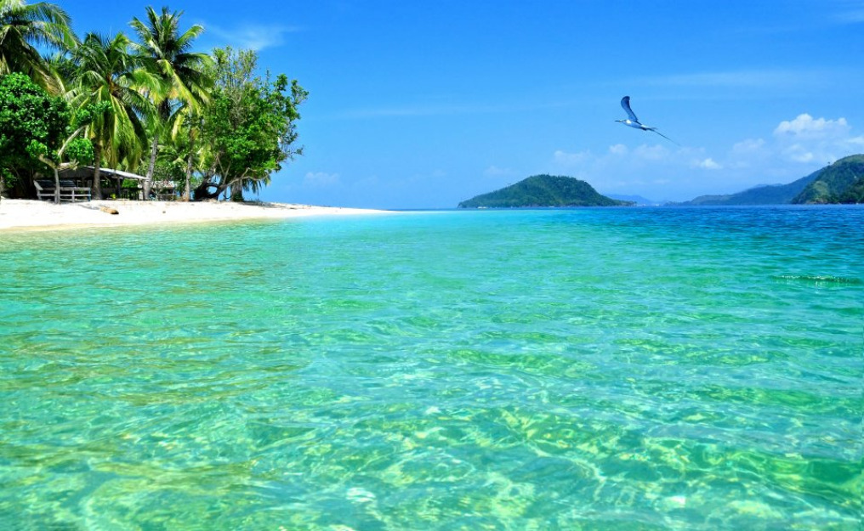
Pagang Island

Padang
West Sumatera

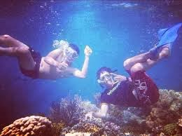
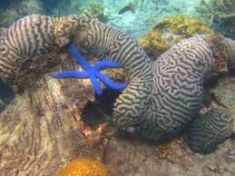
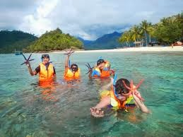
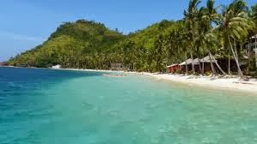
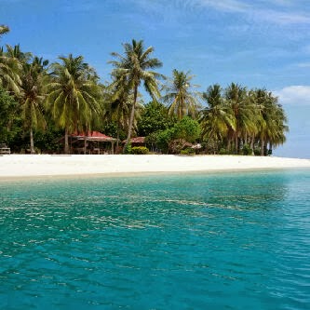

Itinerary
Day One: (Lunch, dinner)
Welcome to Padang City. Meeting point in the Carlos Losmen Bungus, the journey to the island pagang. Once the island pagang may perform activities such as swimming, snorkeling, trecking, banana boat until lunch time. Then free program until dinner time.
Day Two: (breakfast)
After breakfast get ready to visit the other islands (Optional Termination Island / Island Pasumpahan / Sikuai)
Price : IDR 670.000,00/pax

Includes :
- Island admission tickets
- Tickets boat
- Life jacket
- Snorkeling
- Banana boat
- Eat according to the program
- Coffee break
- Free camera water

Excluded:
- Personal expenses (shopping, laundry, telephone etc.)
- Tour out of itinerary

**minimum depart 6 person
**Subject to Change

Contact us :
Shirotol Jannah Tour & Travel
Jl. Mangga No. 41B Pekanbaru
Tlp : +62 761 29076
Hp : +62 852 7811 1165
Email : shirotoljannah@gmail.com
Web : http://travelhebat.com

